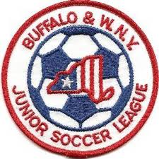
Buffalo & Western New York
Junior Soccer League
League Information Meeting
April 29, 2019

Roll Call of Member Representatives

Treasurer’s Report
Recognition and Reports of Related Organizations

District Commissioner-NYSWYSA Buffalo Referee Unit
Upstate Women’s League Epic Center
Buffalo District Soccer League Other

League Reports

1. Review of new website
2. Rosters, Player Pass and Risk Management Issues
3. Registration
4. Field Issues
4. U10 players retreat
5. Game Reschedule Process
6. Standings
7. U13-19 Alignments & Schedules
8. U13-19 Schedules
9. Odenbach Tournament

Corporate Governance Matters

1. Draft Minutes of Annual General Meeting 10-15-19
2. Communication Regarding Request for Special Meeting
3. Upcoming Board Vacancy
4. IRS Tax Issues
5. NYS Workers Comp Issues
6. Non-Member Club team participation/registration for League play
7. US Club Soccer
Adjournment

Next Meeting: Monday, August 5, 2019 7:30 PM

