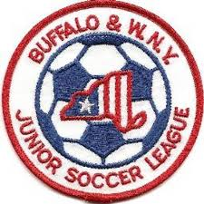Buffalo & Western New York
Junior Soccer League
League Information Meeting
August 10, 2020

Roll Call of Member Representatives

Treasurer’s Report
Recognition and Reports of Related Organizations

District Commissioner-NYSWYSA Buffalo Referee Unit
Upstate Women’s League Epic Center
Buffalo District Soccer League Other

League Reports

1. 2020 Odenbach Tournament Review
2. 2020 Alignment Process Review
3. 2021 Preliminary Potential Procedure Changes-Team Registration
4. 2021 Team Naming Convention
5. 2021 Play Season Potential Changes
6. 2021 Fee Structure
7. New Agreement with Referee Association 2021-2023

Corporate Governance Matters

1. Upcoming Elections for President, Treasurer and Trustee
2. NYS Workers Comp Issues Settled-Neal S.
3. IRS Matter
4. Updated Club Representative Contact Information
Adjournment

Next Meeting: Annual General Meeting Monday, October 5, 2020 7:30 PM

2021 Play Season Potential Changes
- 2021 Play Schedule (separate sheet)
- Field Issues
- Number of Teams – limits on number per club or age group based upon field availability
- Youngest Birth Year to Play-2012 or 2013
- Oldest Birth Year to Play-2001 or 2002
- U8 Divisions to Follow USYSA Guidelines for Rosters, Players on Field and Game Length

- If 2001’s play-revamp groups offered to delete U17 and U19, replace with U18 and U20
- Potential elimination of the 2002’s (U19) and cap at U18 with U19’s going to the Adult Leagues

