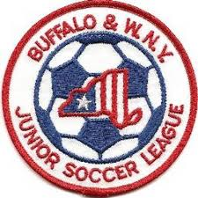
Buffalo & Western New York
Junior Soccer League
Board of Directors Meeting
April 15, 2019
6:00 PM
- Finance Report – Neal S.
a) Treasurer's Report
b) IRS Updates
c) Other Issues Outstanding
- Website Update - Bob L.
a) Design - Done!
b) Populating Data - Ongoing (looking for content)
c) 2019 Season Registration - Complete 2019, minor revisions for 2020
d) Odenbach Registration - late but ready
e) Information Update Protocol
- 2019 Season Status Report - Bob L.
a) Schedules - Bob L.
b) Reschedules - Bob L.
c) Referee Report - John K.
d) Southern Tier Storm update
- 2020 Season - All
a) "Premier" Team issues
b) Policy & Procedure changes (if any)
- League Meeting April 29, 2019
2019 Tentative Schedule

Board Meetings
Dec. 3, 2018
April 15
June 3
July 22
Sept. 30

League Meetings
April 29
Aug. 12
Oct. 14

